***Attention students:***

***In order to demonstrate successful completion of all components in the project, please use screenshot(s) to show each completed action step as specified on the instructions page.***

**Identity and Access Management**

1. Proof of Assigned roles and AD assignments
   1. Andrew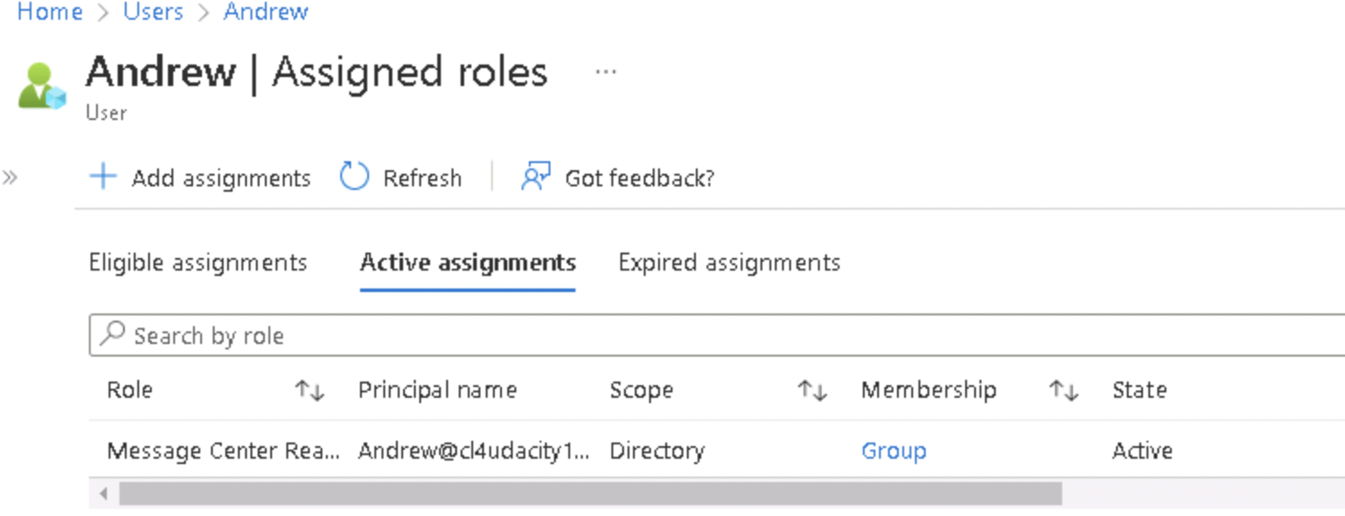
   2. Chris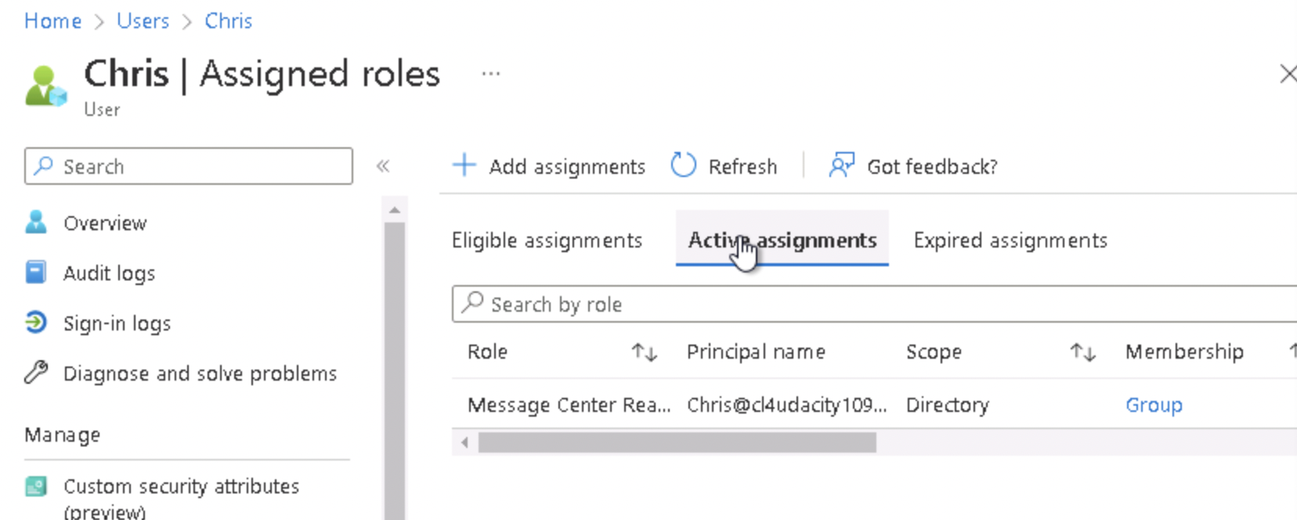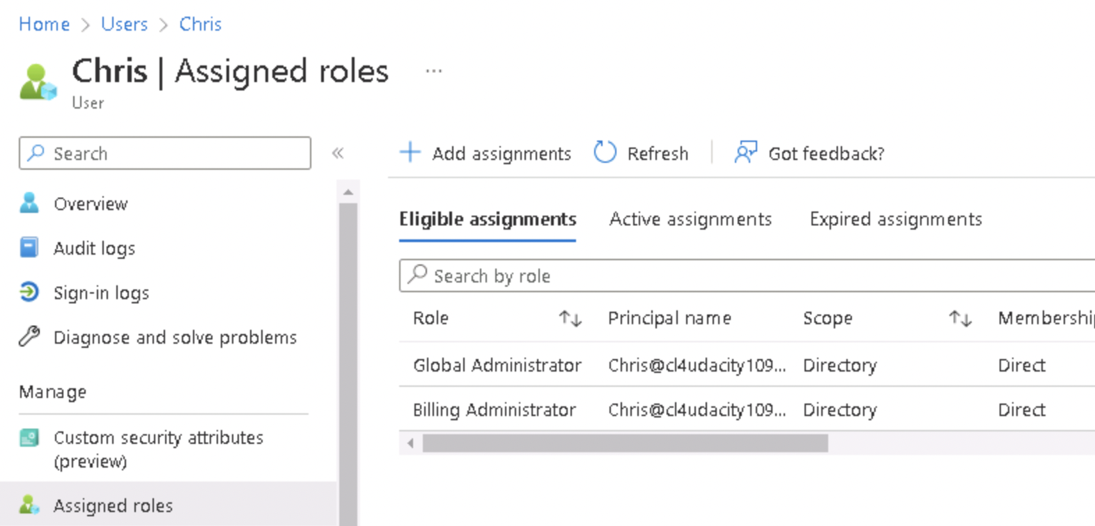
   3. Karl  
      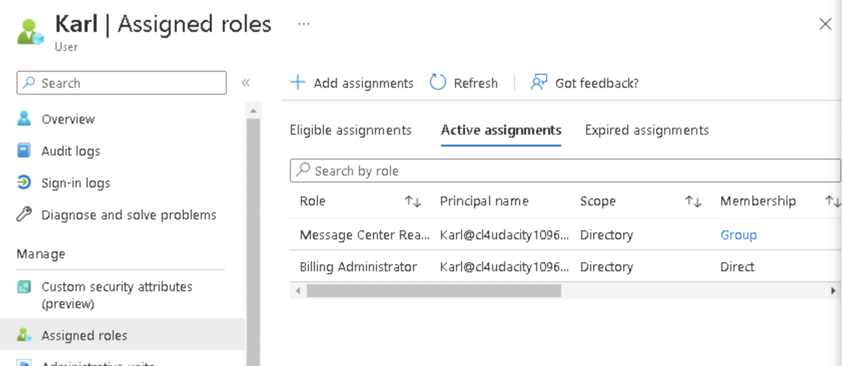
   4. Lora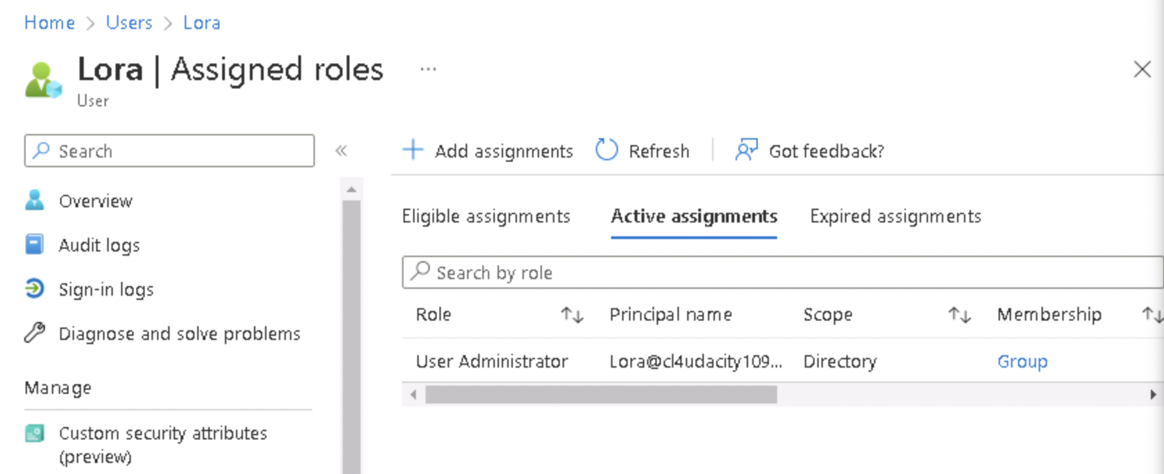
   5. Neelima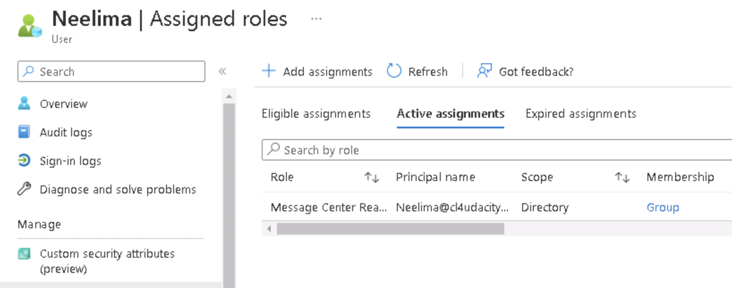
   6. Neha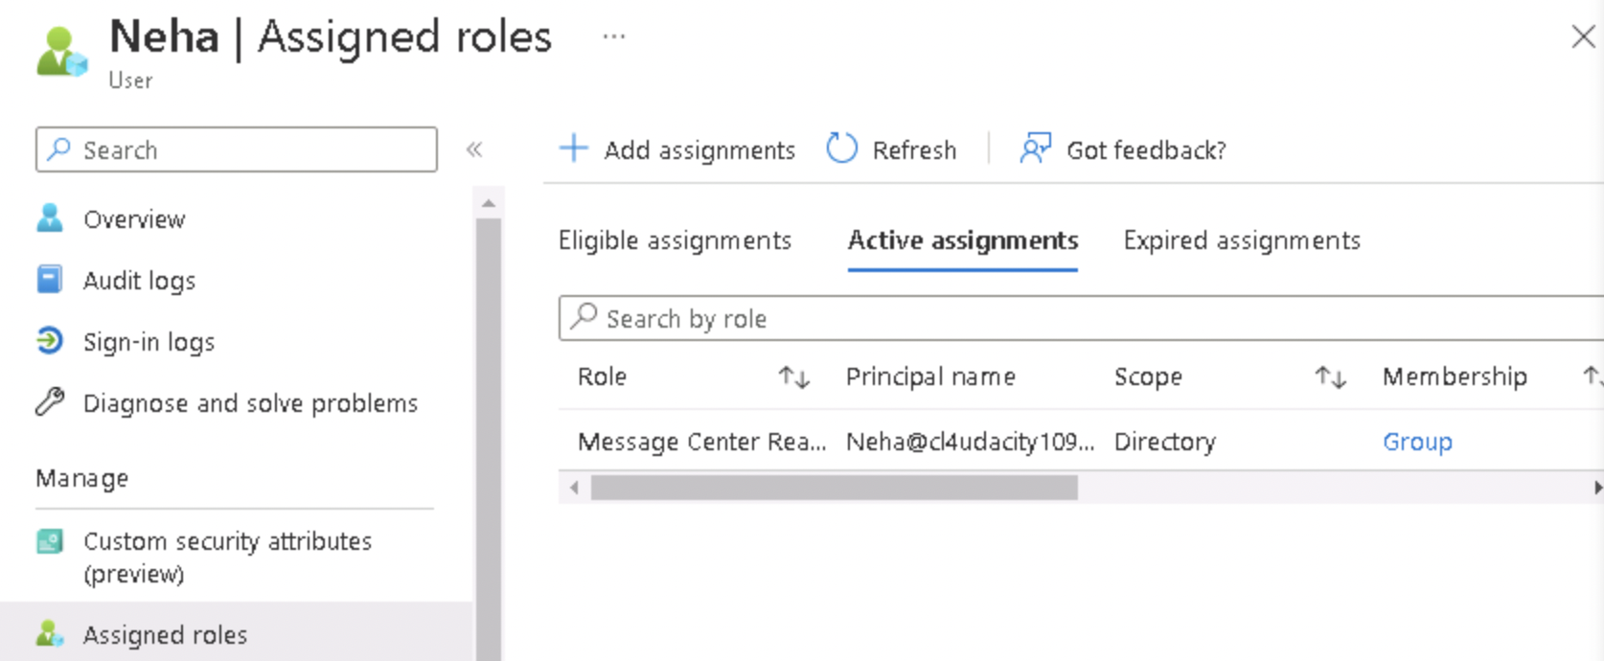
   7. Seth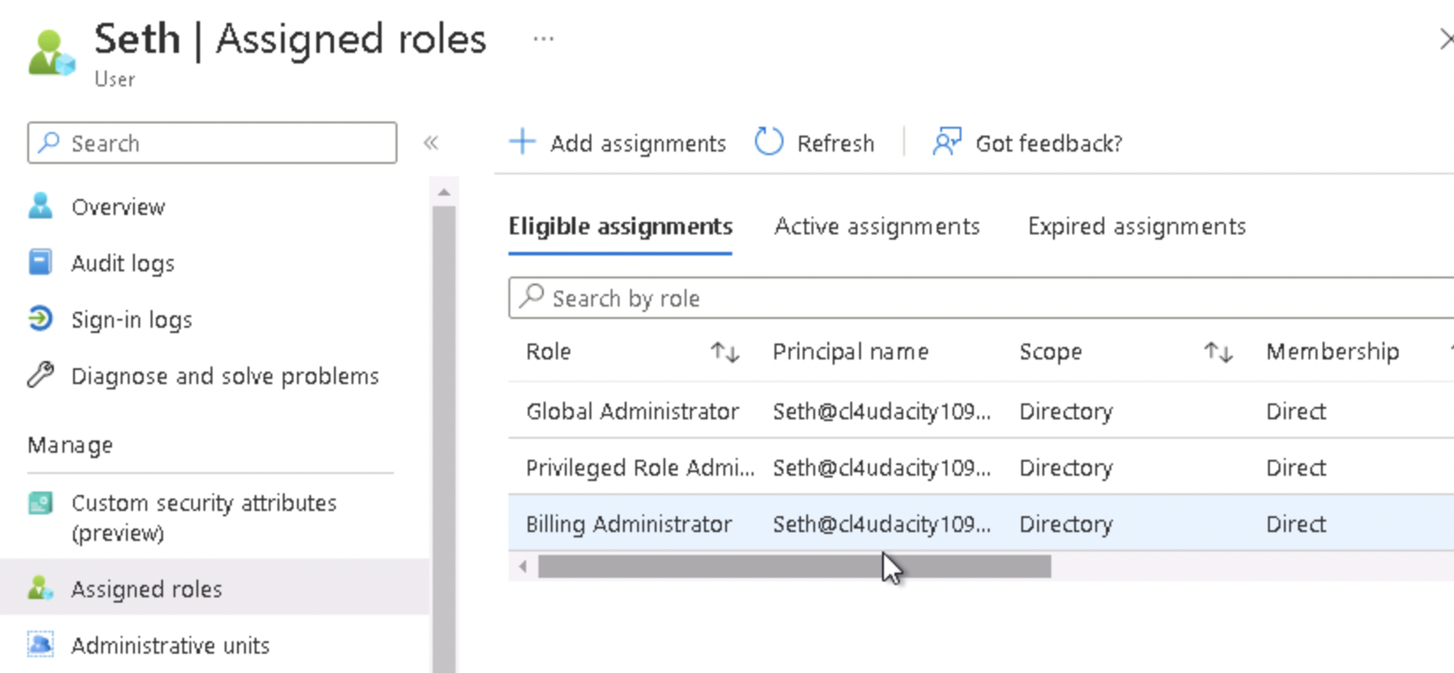
   8. Srinadh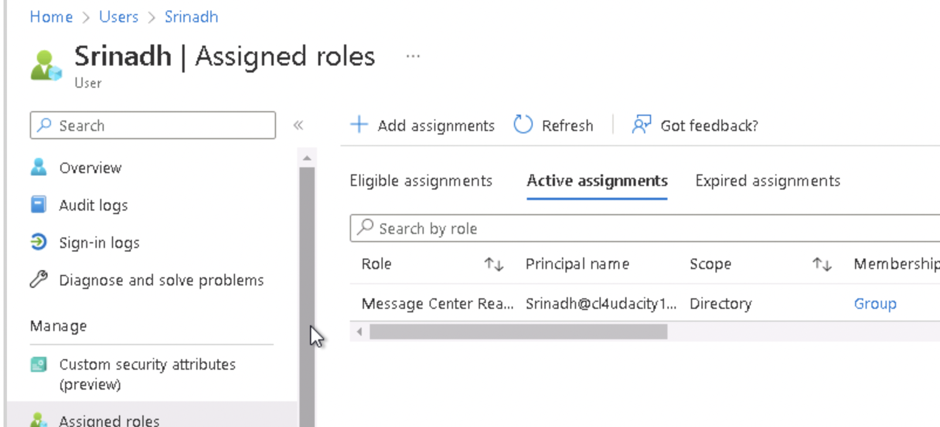
   9. Tom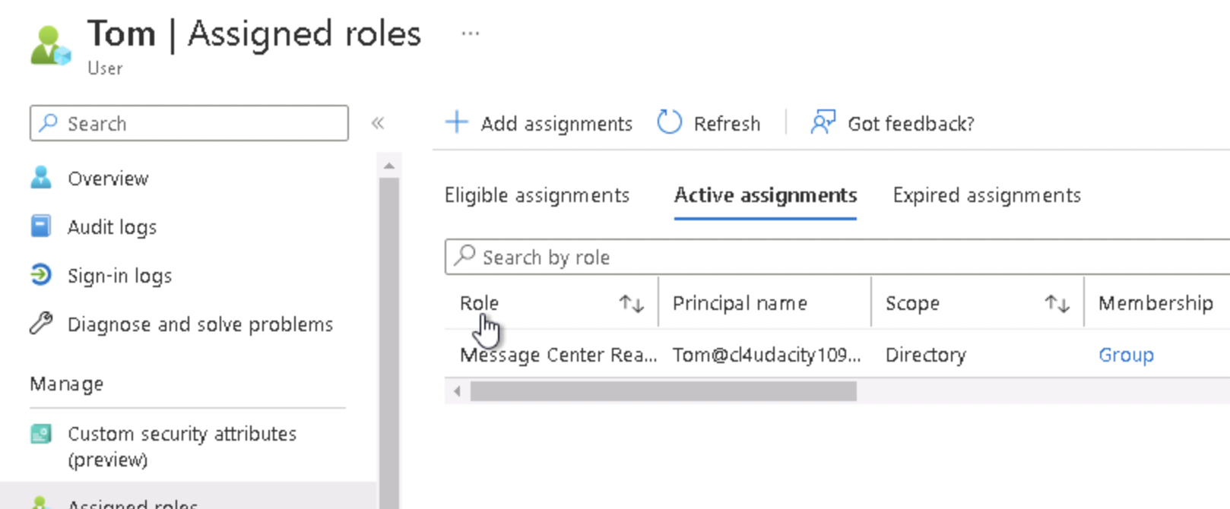
   10. Winifred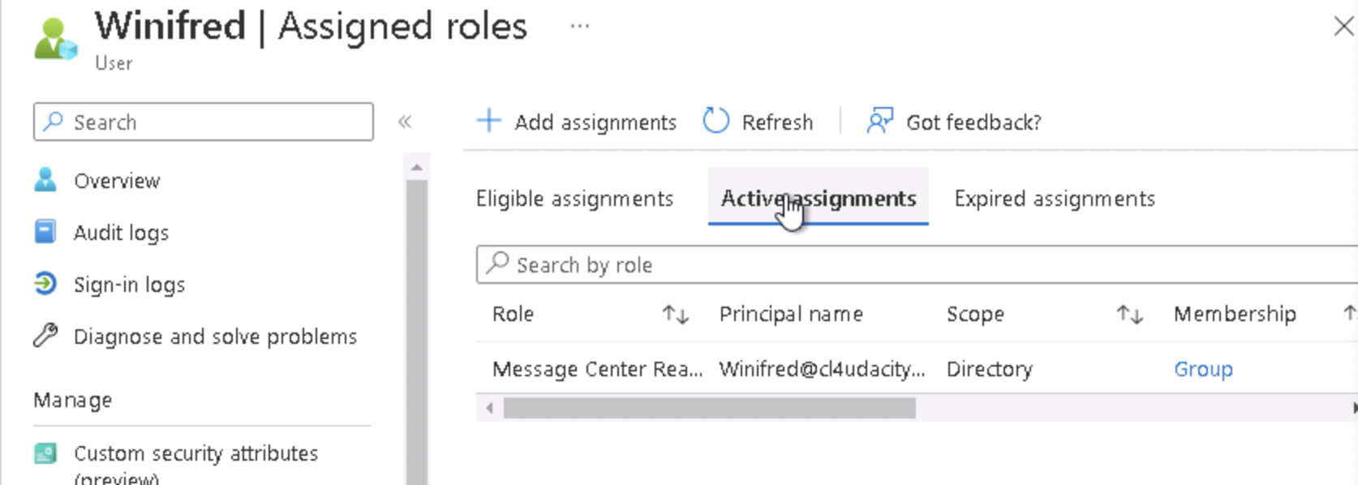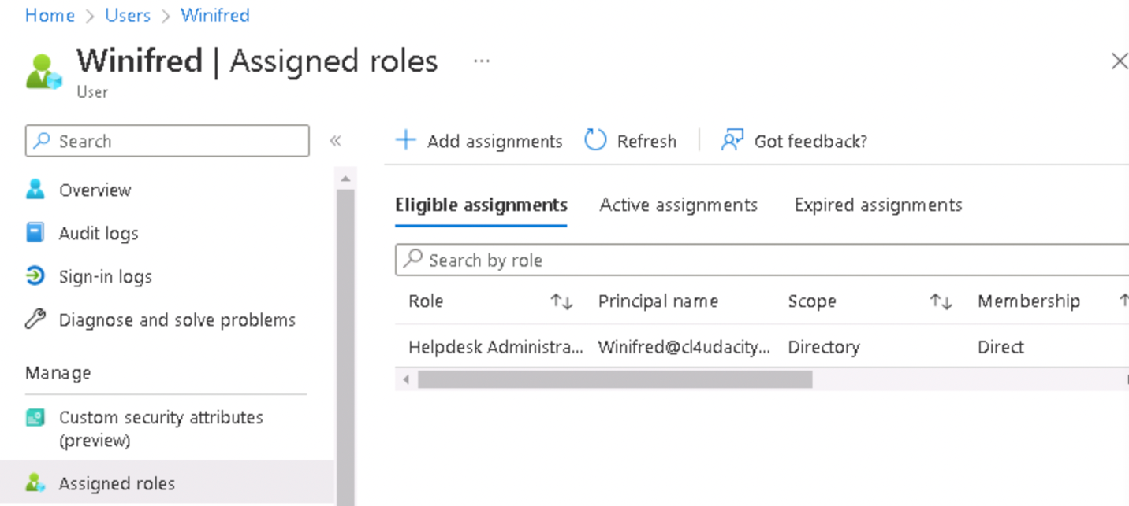
   11. IT Departments  
       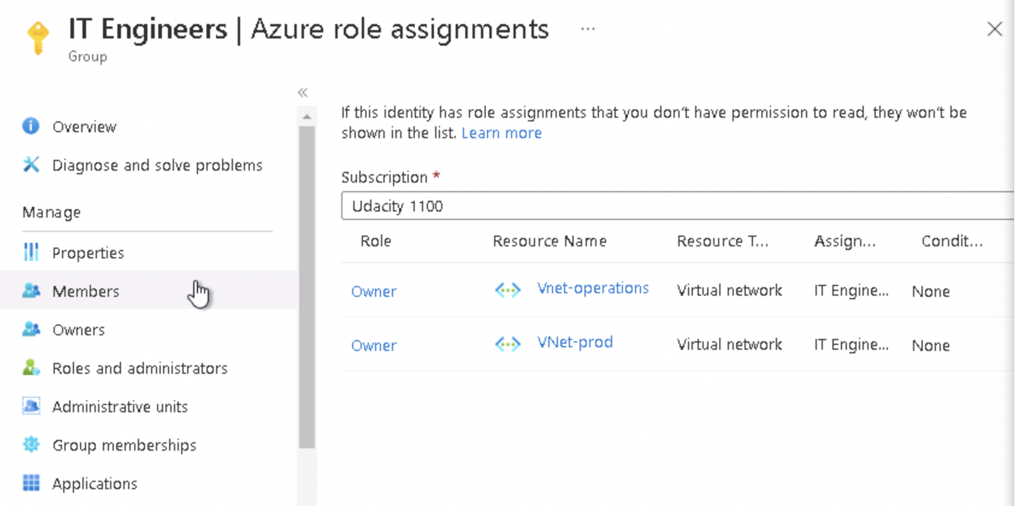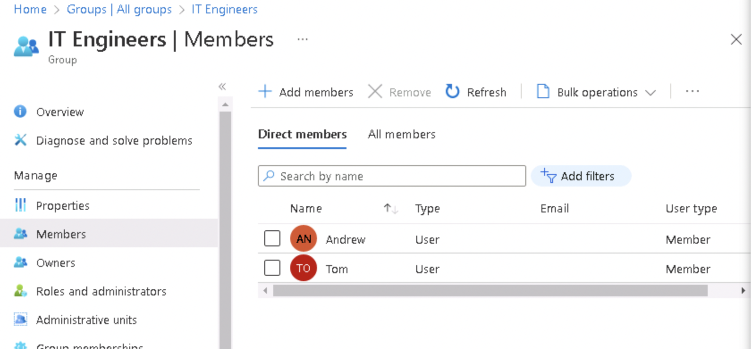
   12. Development Lead

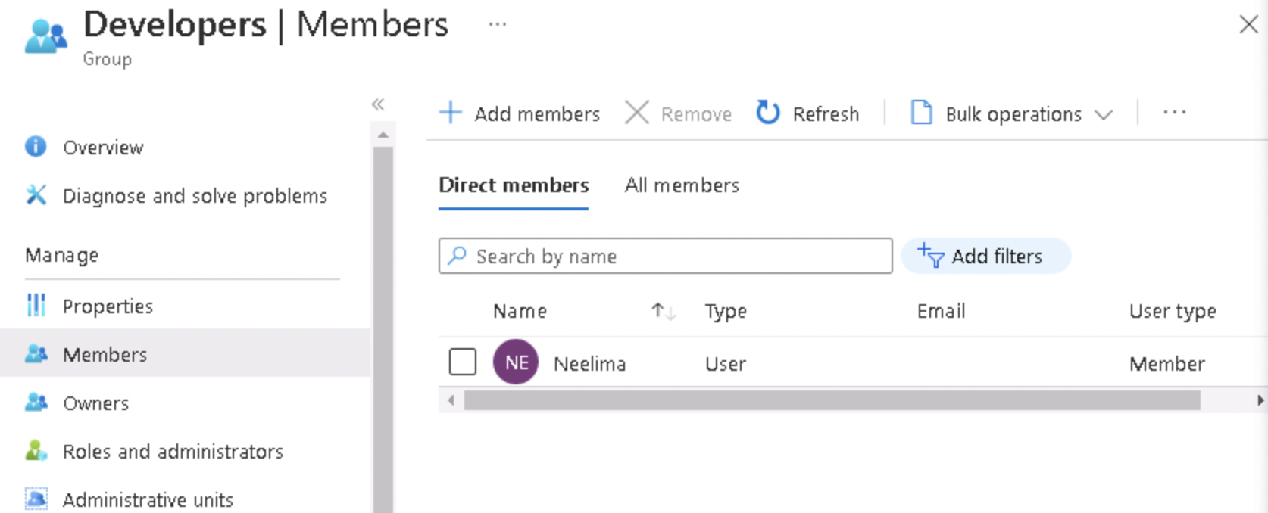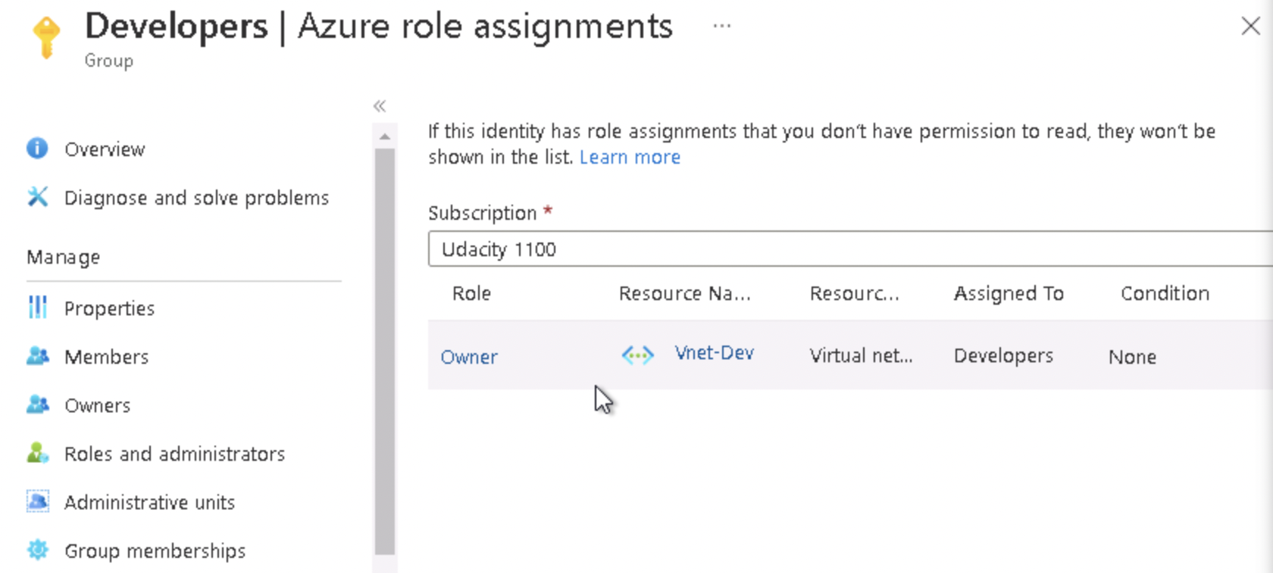

* 1. Lead DBA  
     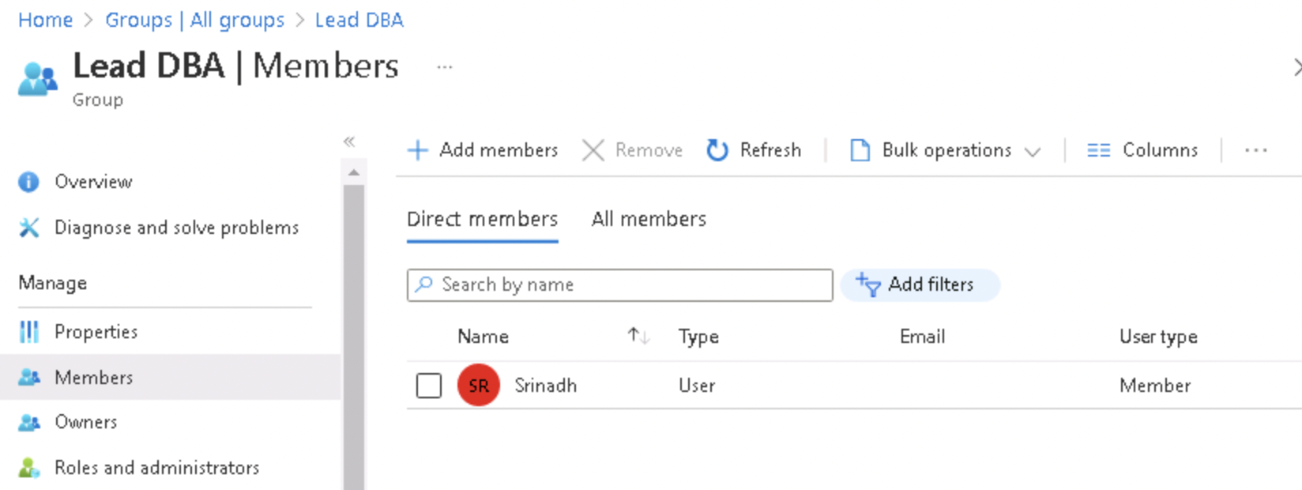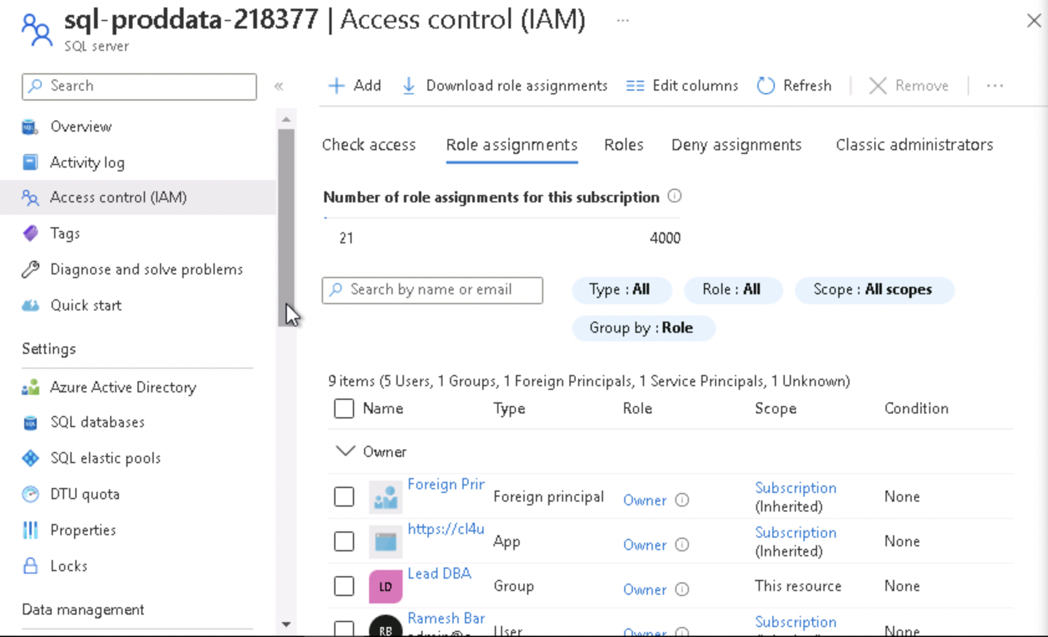
  2. Dev DBA   
     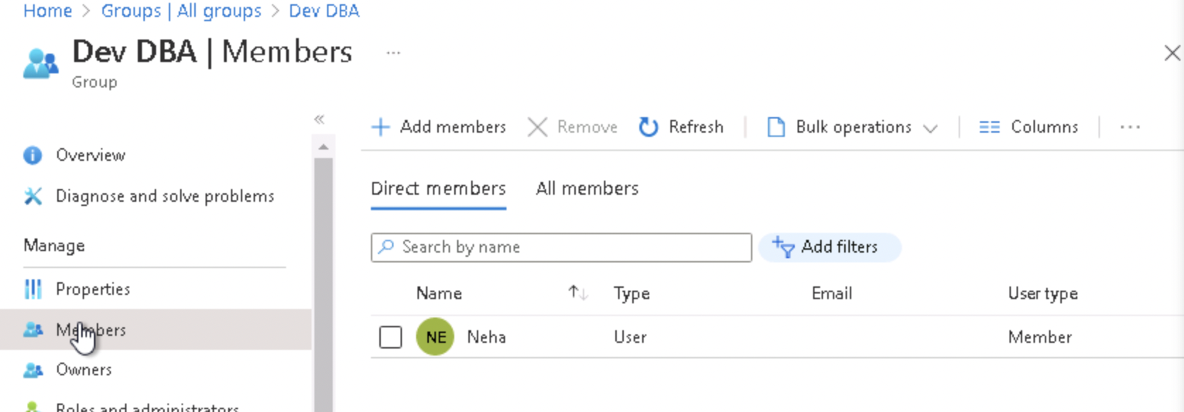

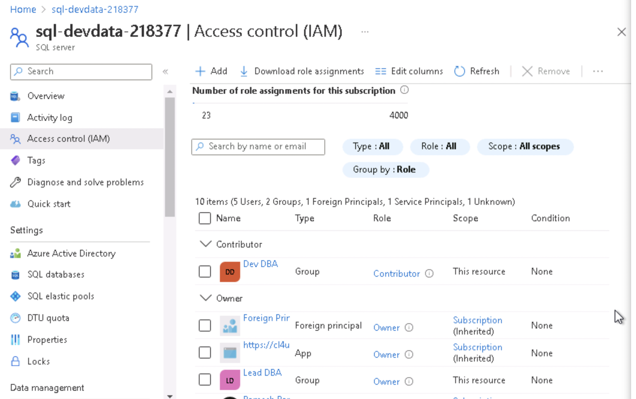

1. Proof of Global Administrator setting with duration, eligibility, expiration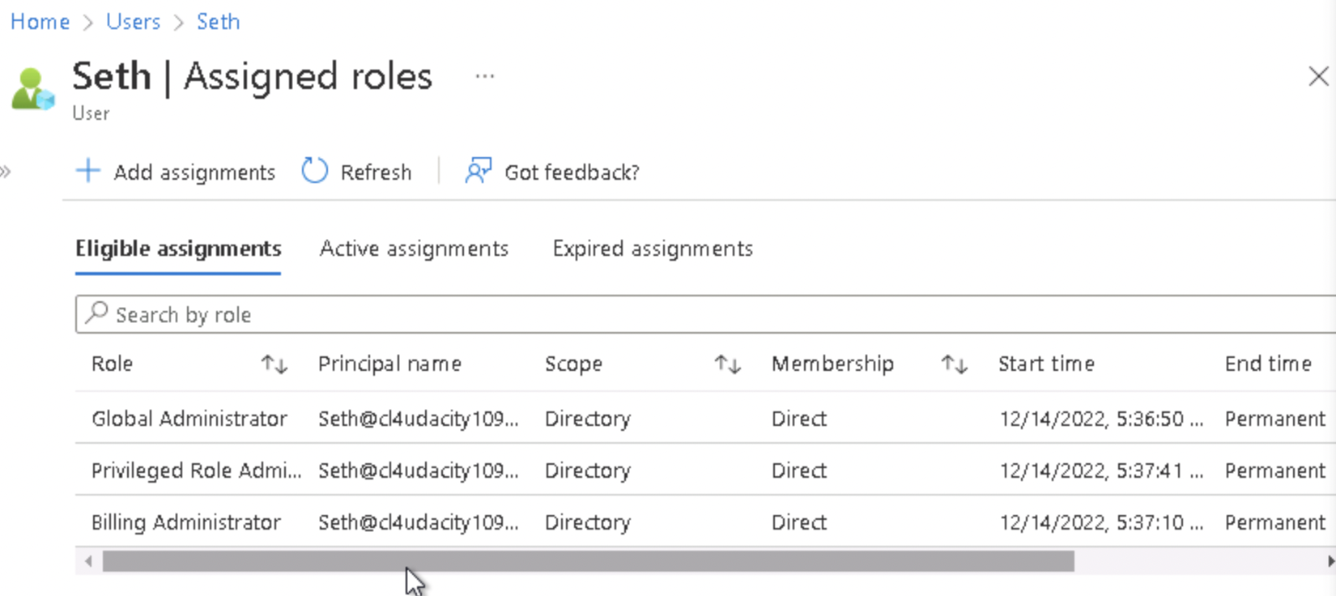
2. Proof of Conditional Access policy all users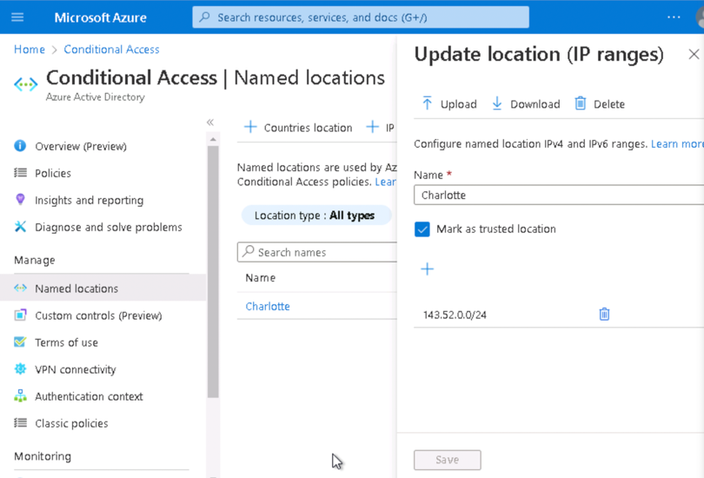

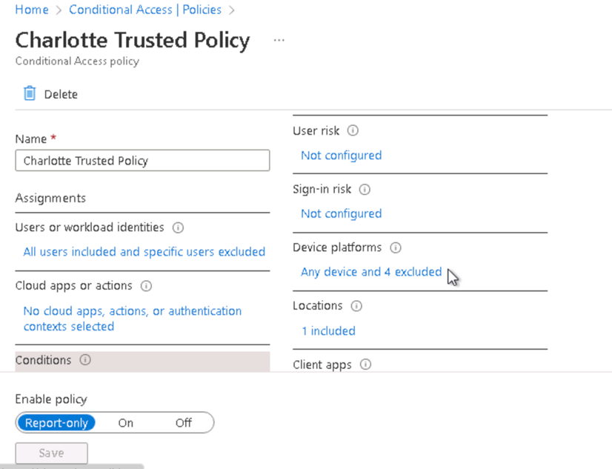

1. Proof of Multi-factor authentication(14 days, Charlotte office info)

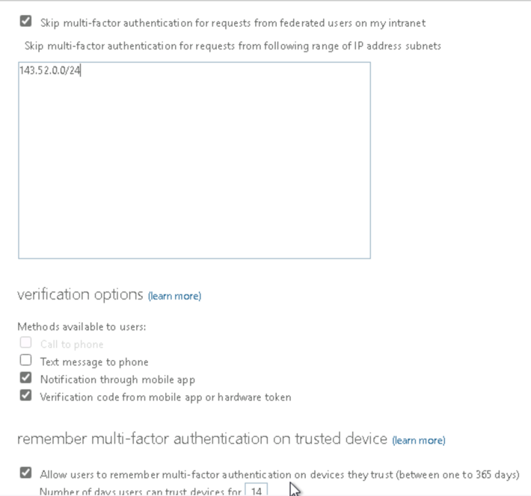

**Network Security**

1. Bastion overview

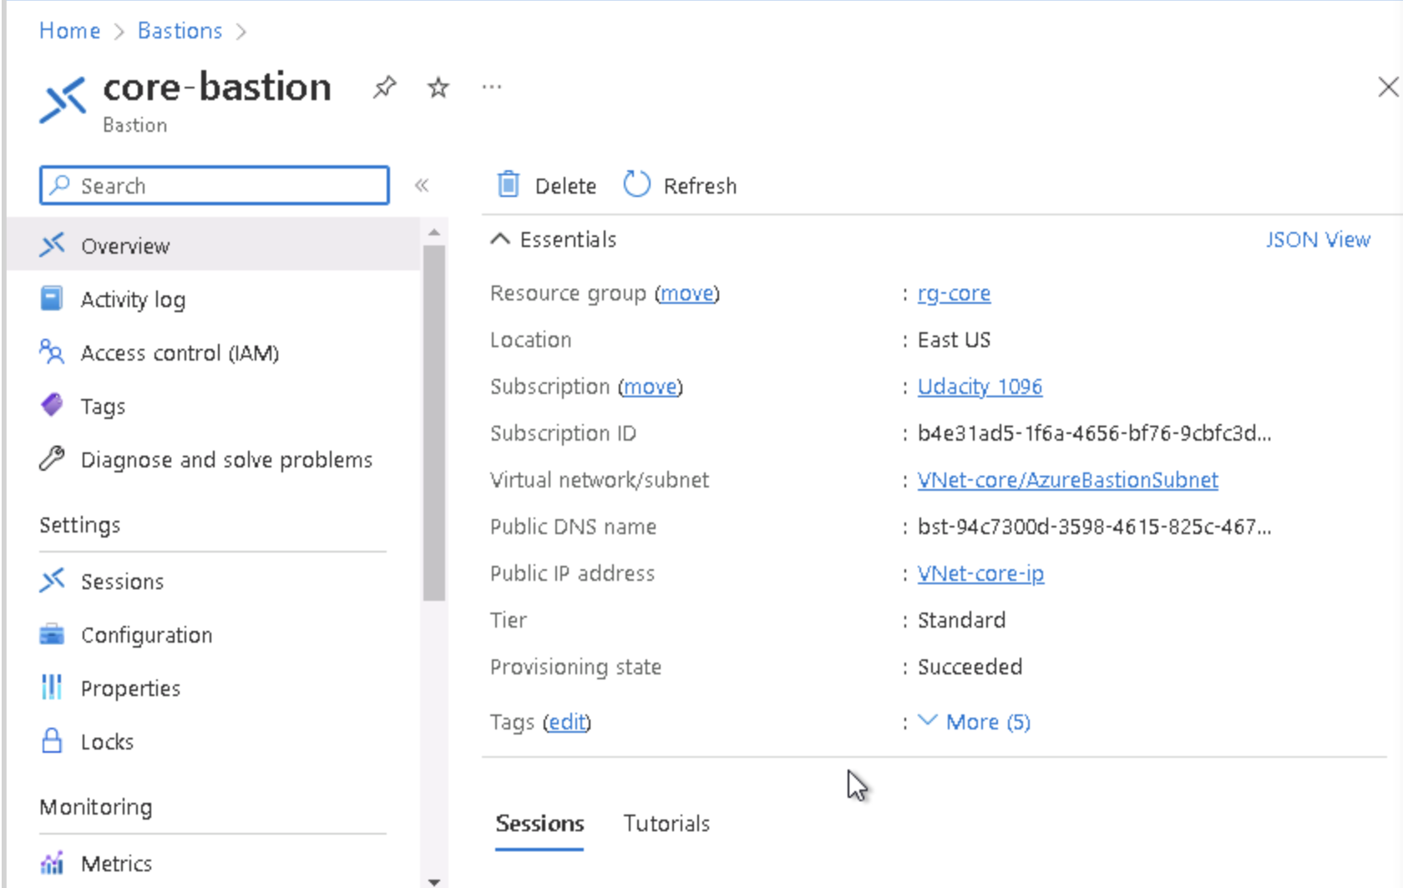

1. Proof of public IP addresses removed (Added 2 screenshoots)

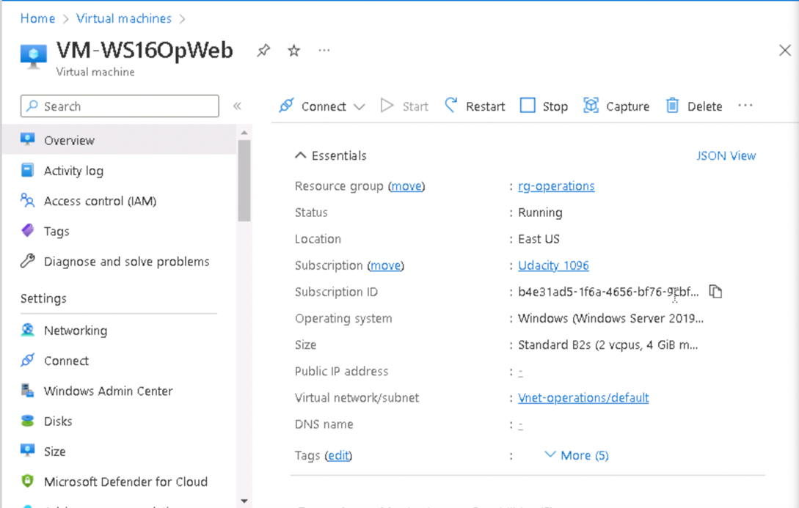

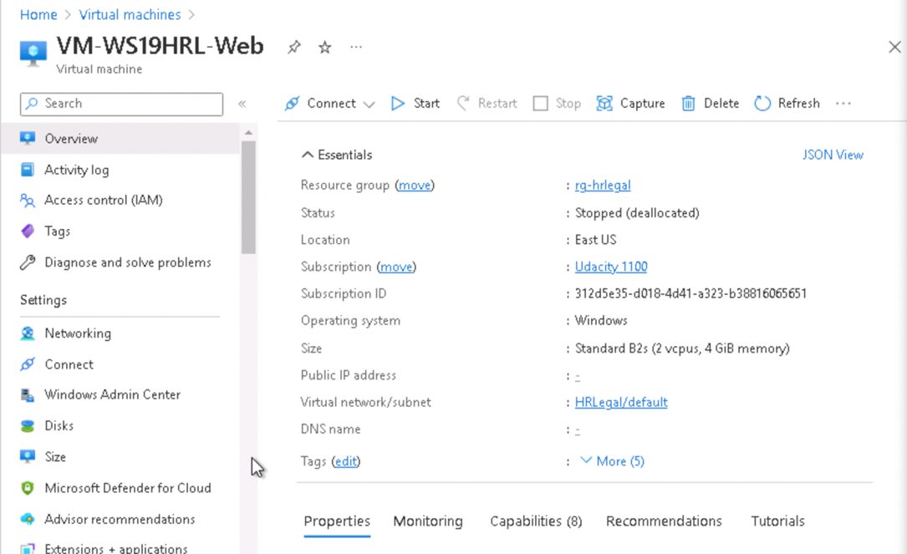

**Data and Encryption**

1. Proof of Encryption types for VM ( devapp,OpWeb,HRL-App,OPApp, HRL-Web)  
   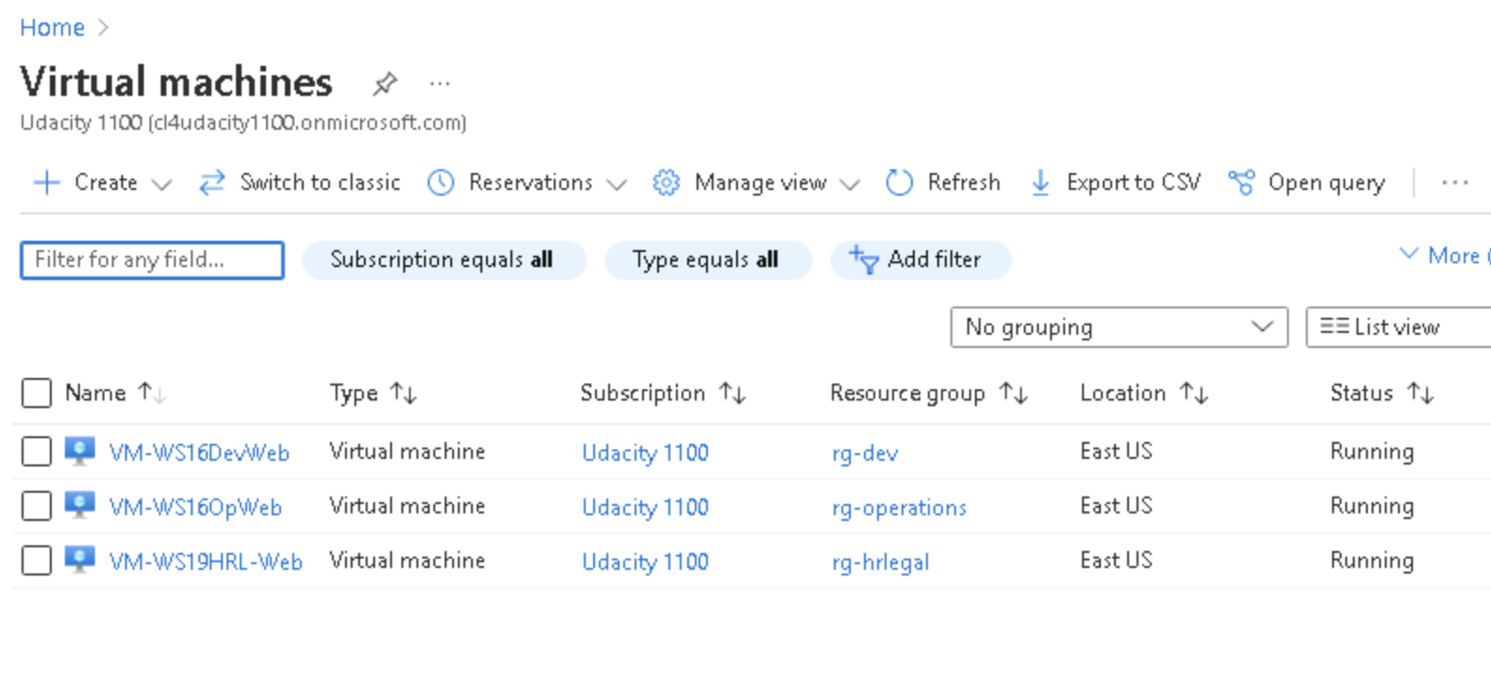

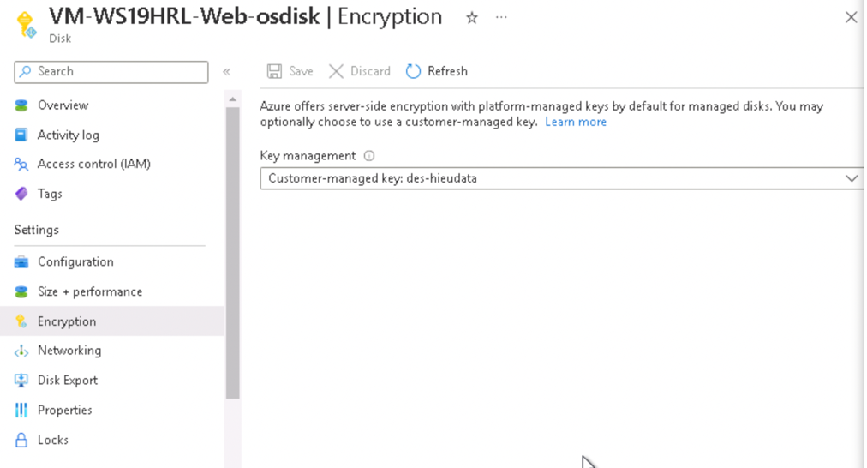  
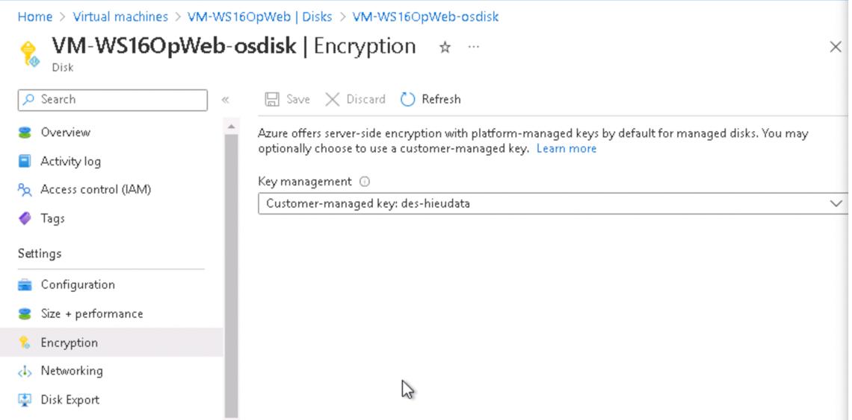

1. Firewalls and virtual networks page
   1. Proof of no public access and TLS for SQL servers(prod, dev)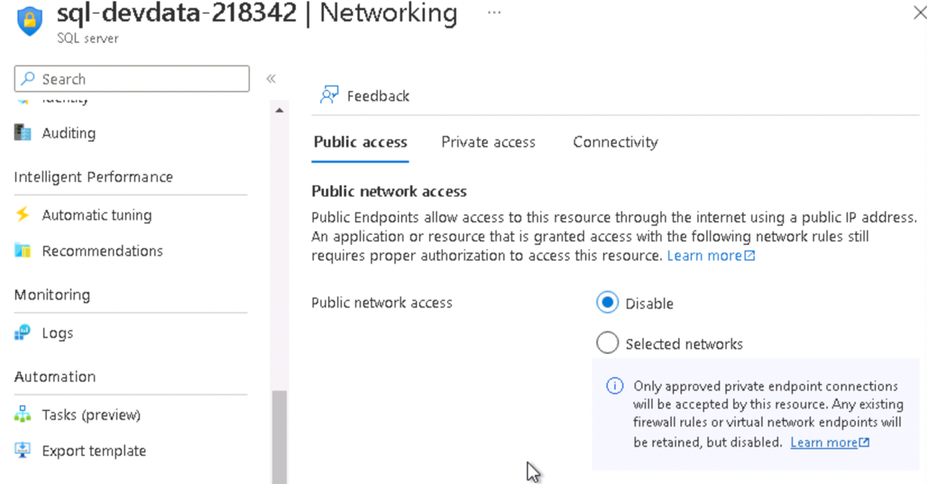  
      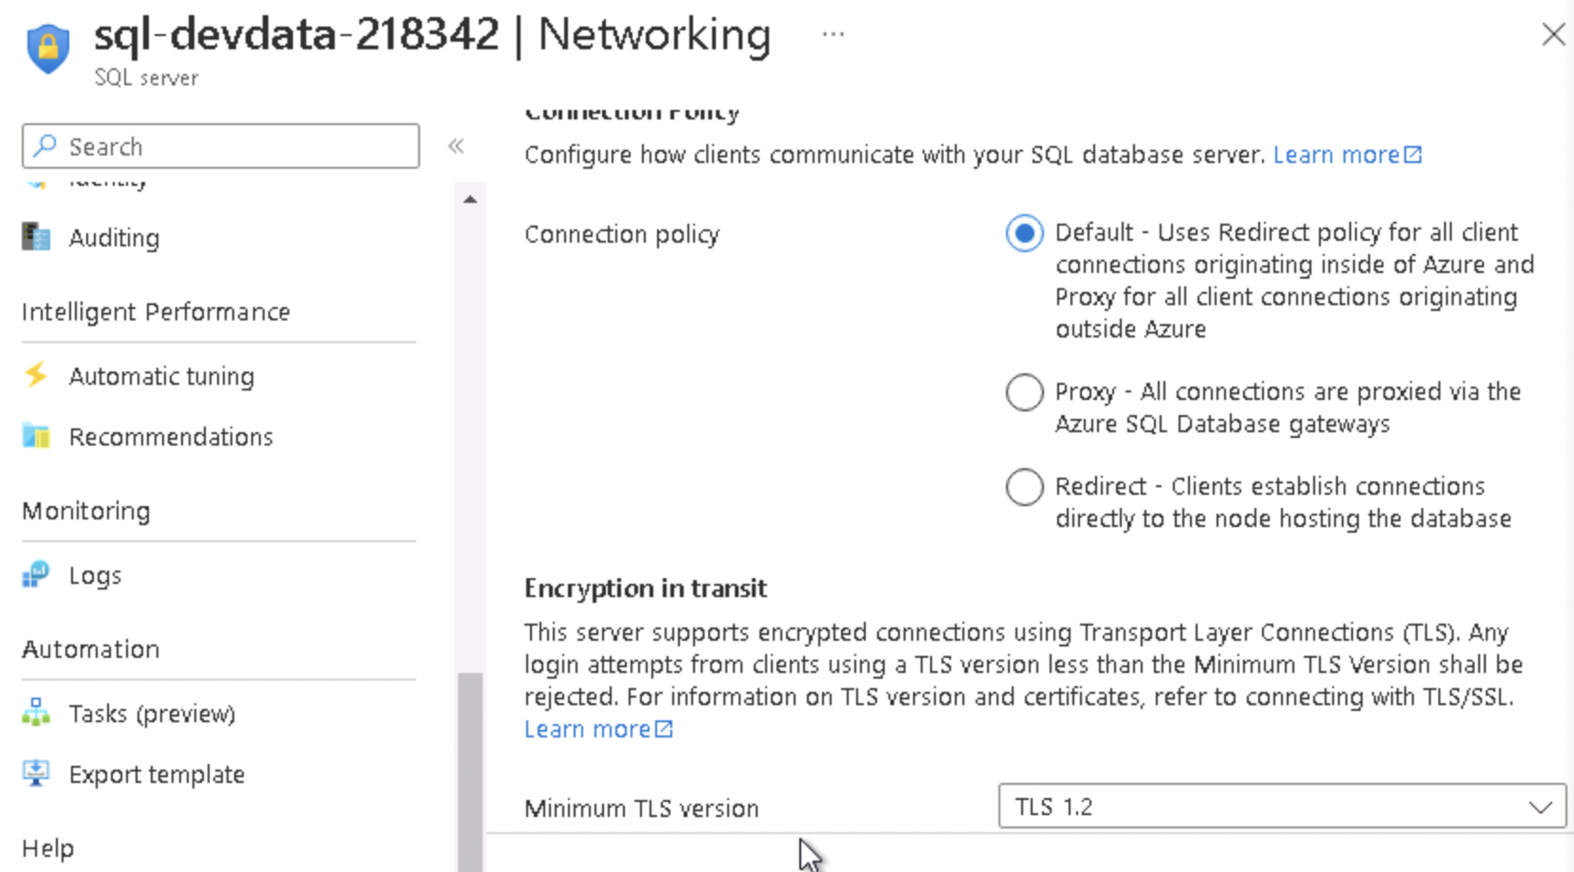

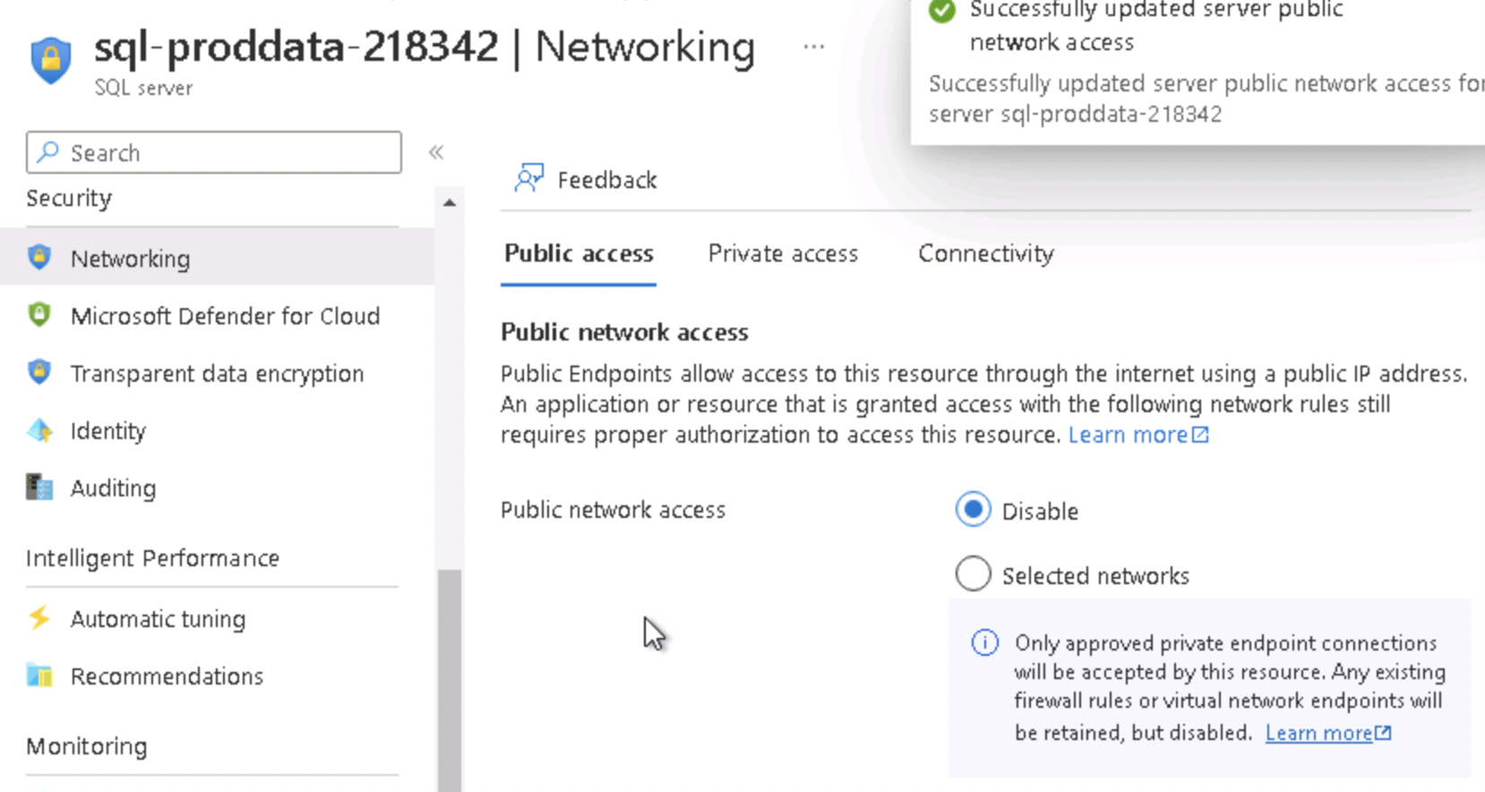  
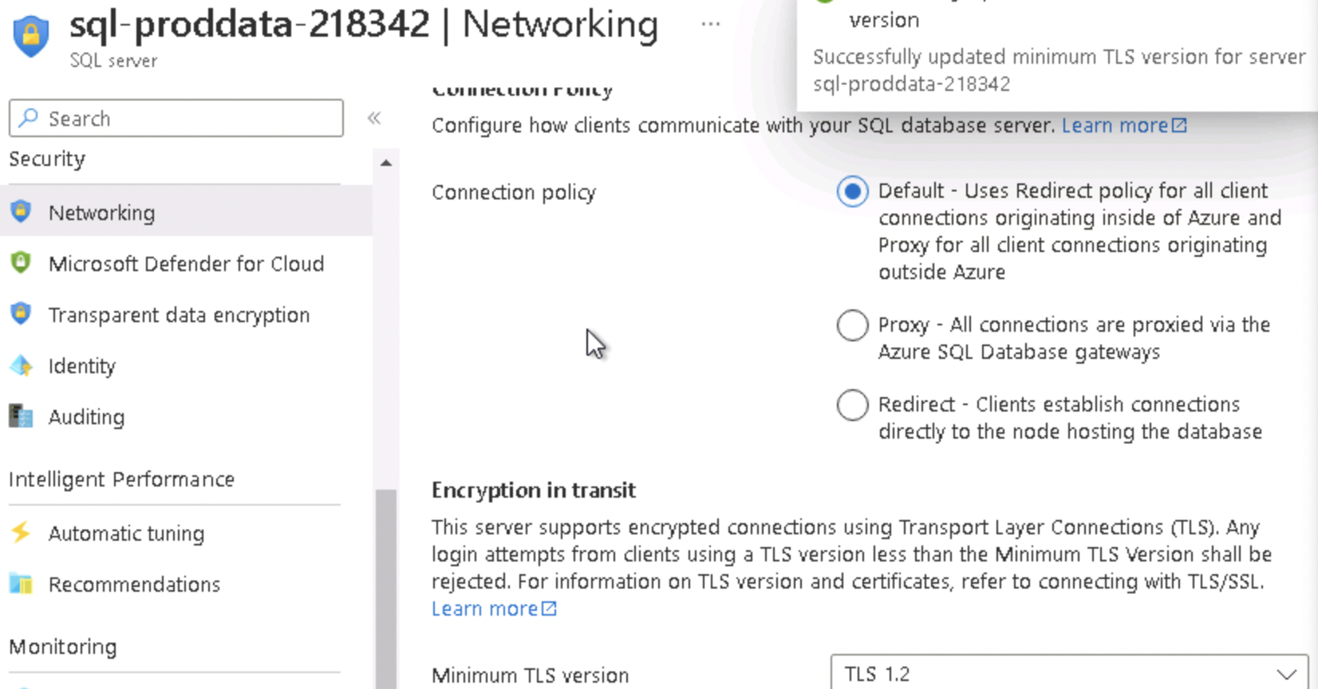

1. Proof of Azure Defender SQL server enabled(prod, dev)  
   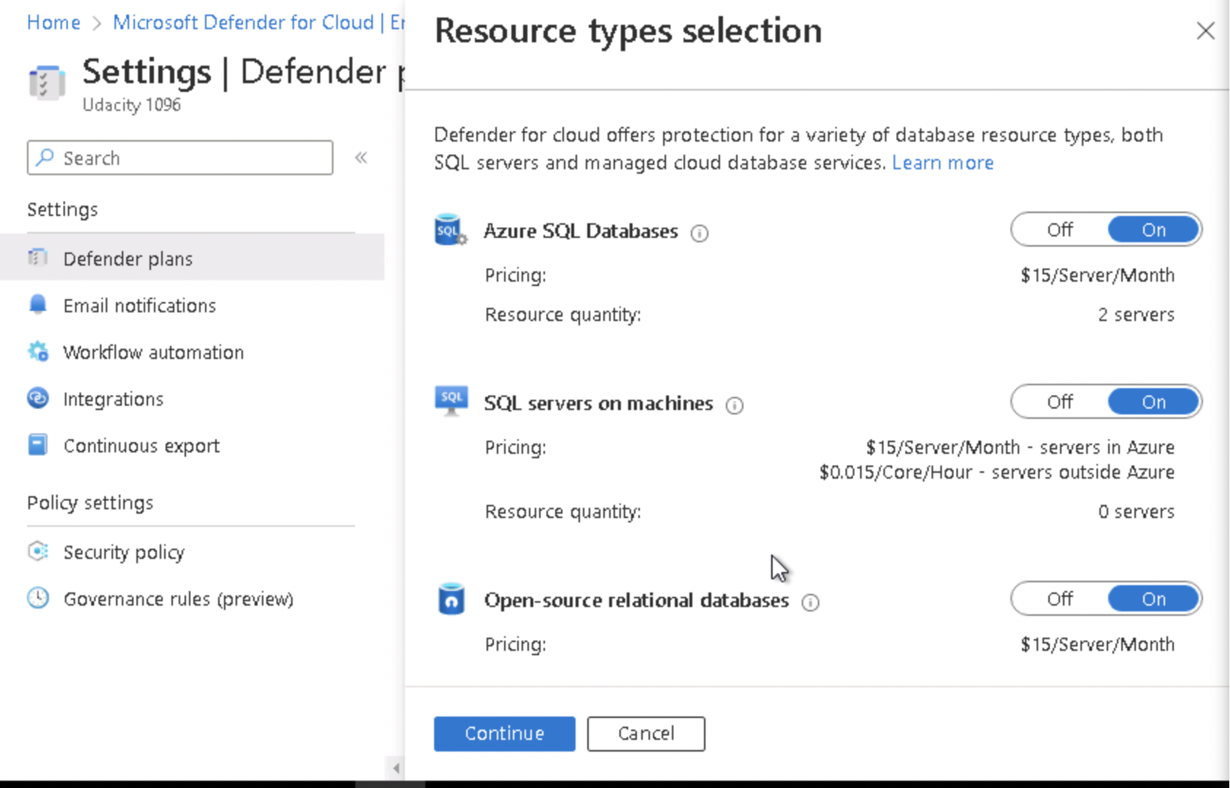
2. Proof of Azure AD authentication for SQL enabled(prod, dev)

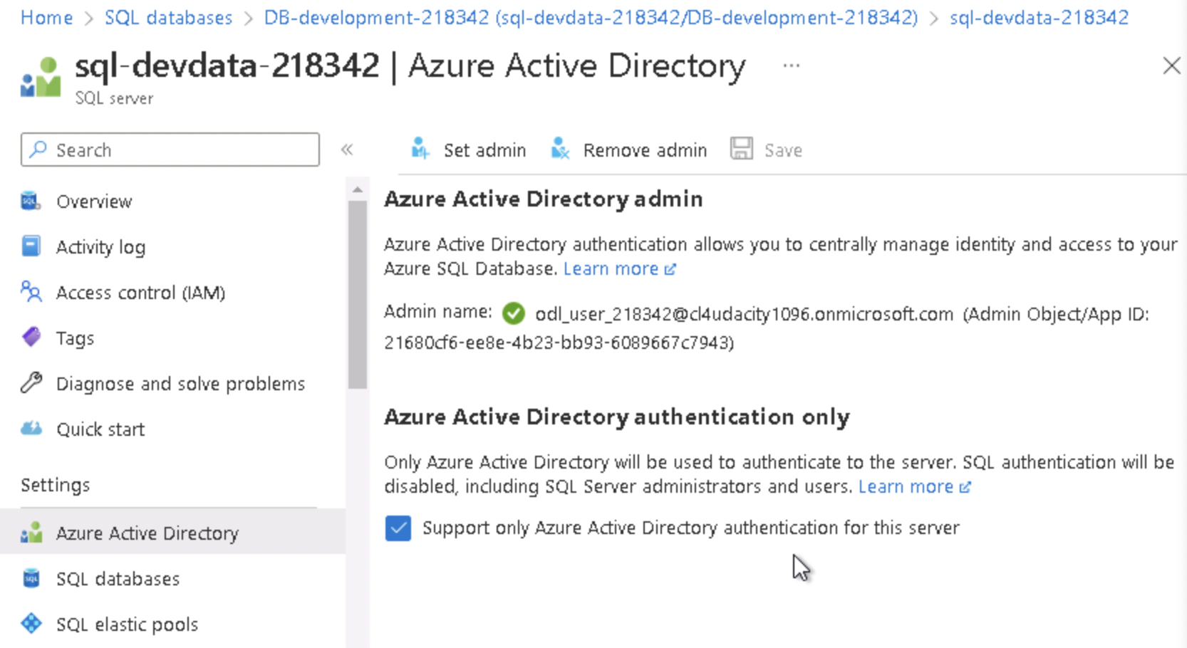

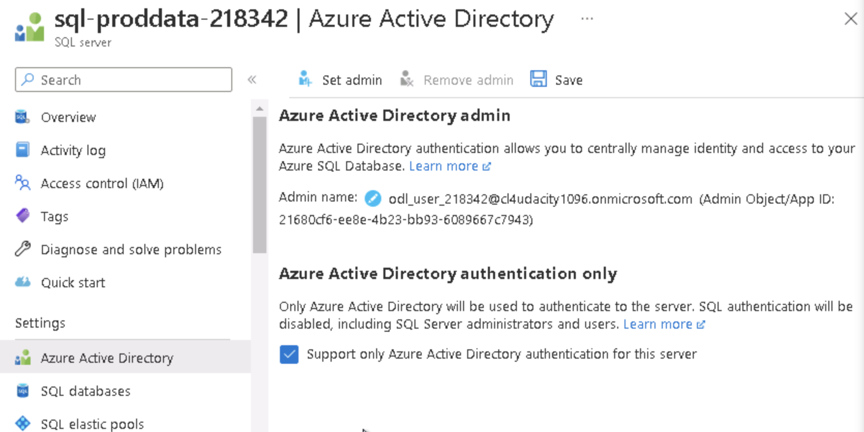

**Cloud Protection**

1. Proof of IaaSAntimalware enabled ( devapp,OpApp,HRL-Web, HRL-App,OpWeb)

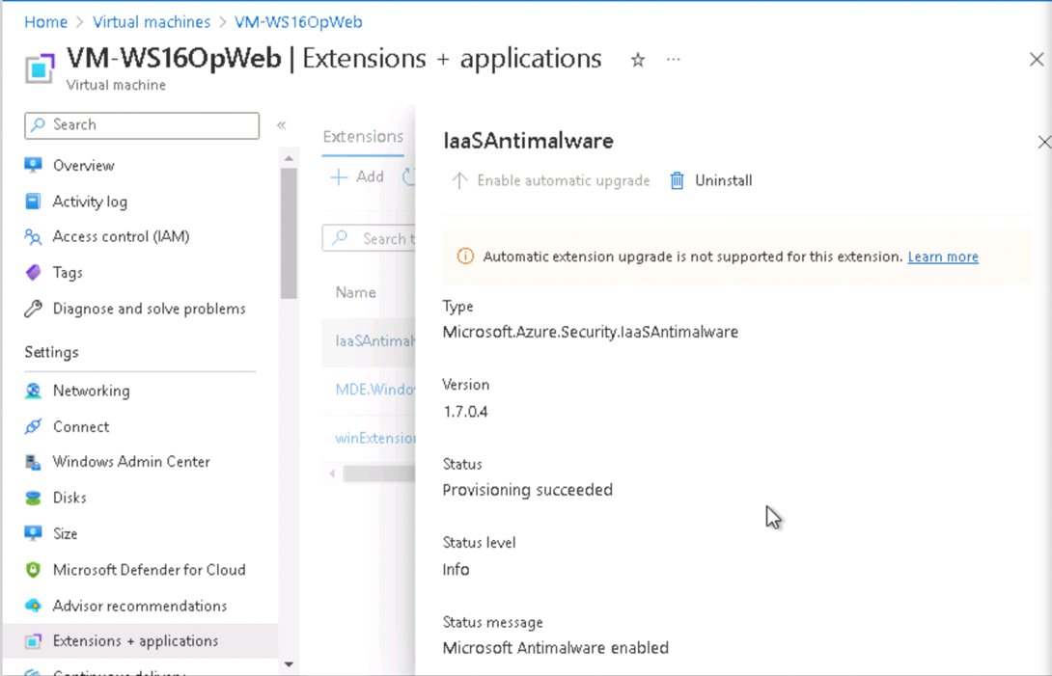

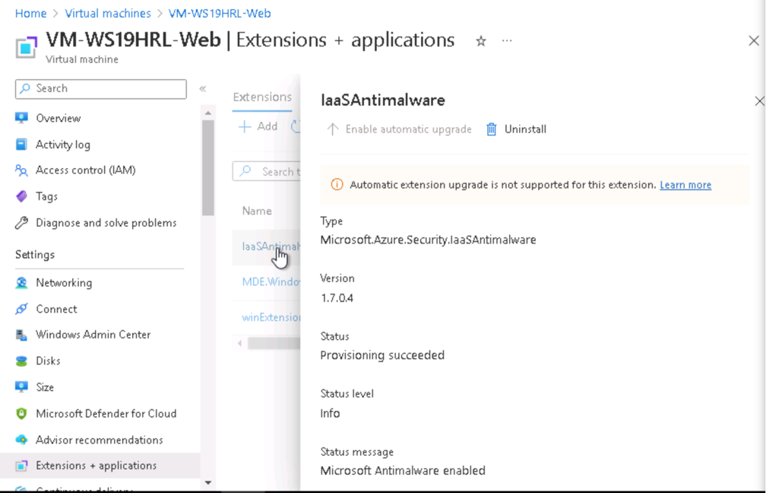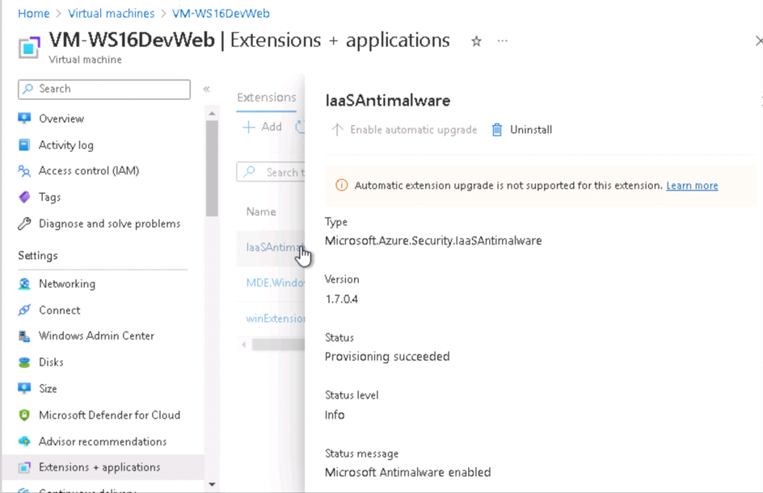

1. Recommendations  
   - MFA should be enables for all subscriptions accounts. -> We need to enable MFA to increase security.  
   - There should be more owner than one owner assigned to subcriptions. -> We need to add more owners to have administrators access redundancy.

- Accounts with owner permission should have MFA enabled. -> To protect the owner account, we need to do that. We can enable MFA defaults or per-user MFA enables.

**Monitoring**

1. Student should identify 3 items from the Audit log and explain what each log shows.

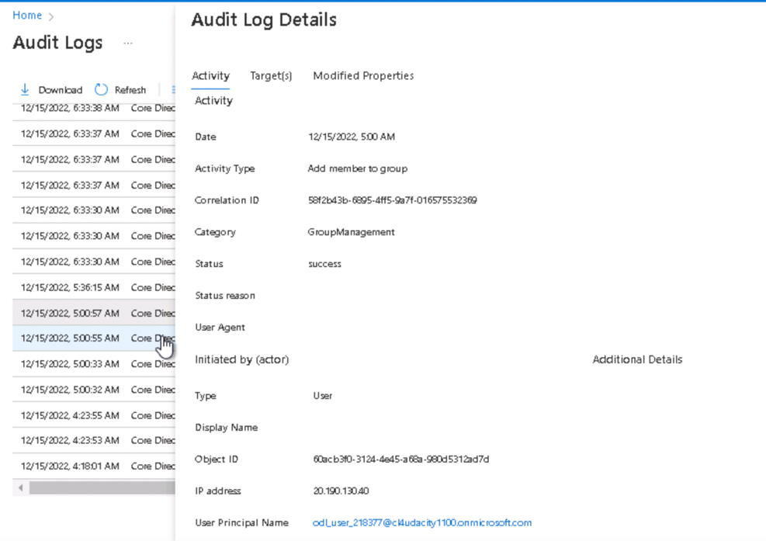

This is the audit log for activity type “Add member to group”. It happened when a new user is added to a group. We can see who adds this user into the group and what has been updated.

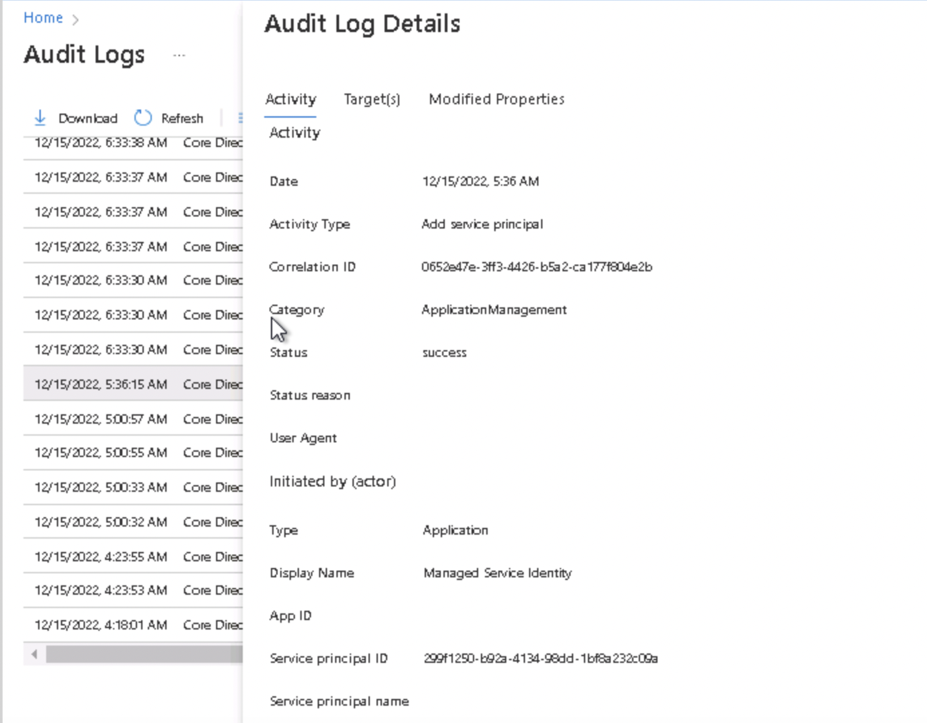

This is the log whenever new service principal added into the system. We can check when and what has been created here.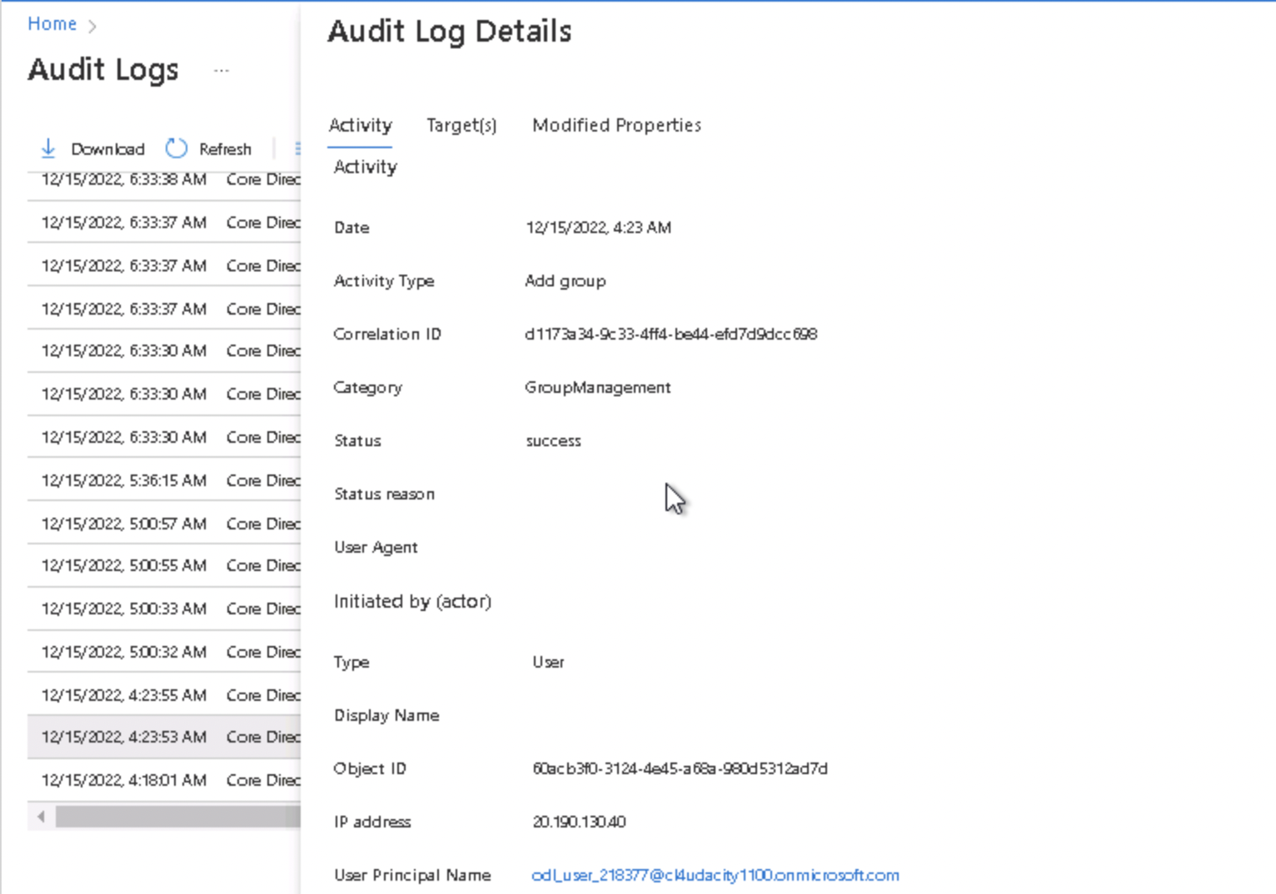

This is the audit log for activity type “Add new group”. It happened when a new group is added. We can see who adds this group and what has been updated.

1. Proof of Azure SQL auditing with Log analytics (devdata,proddata)  
   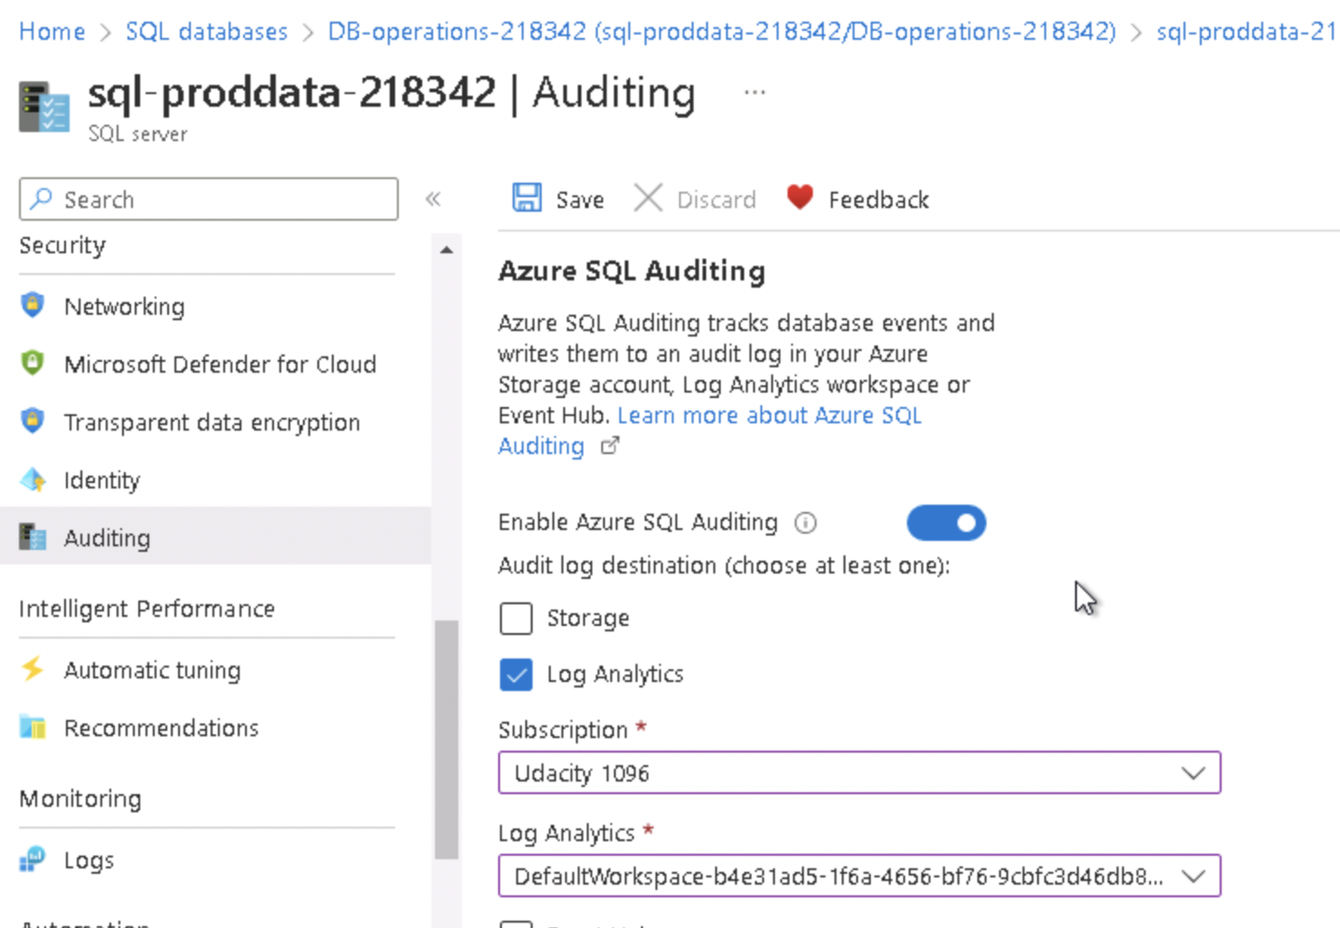

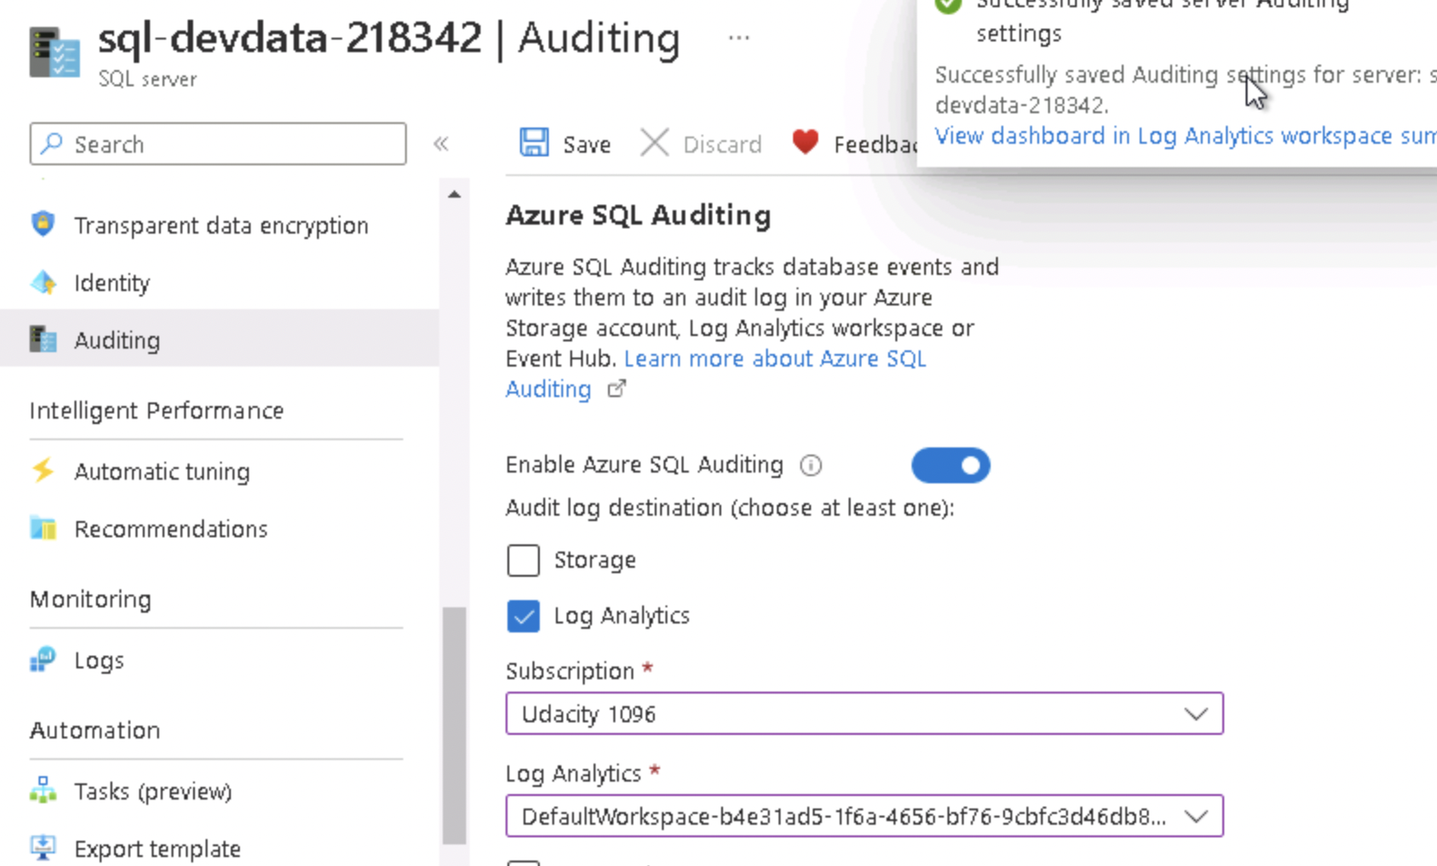

1. Proof of Sentinel connectors (2+)

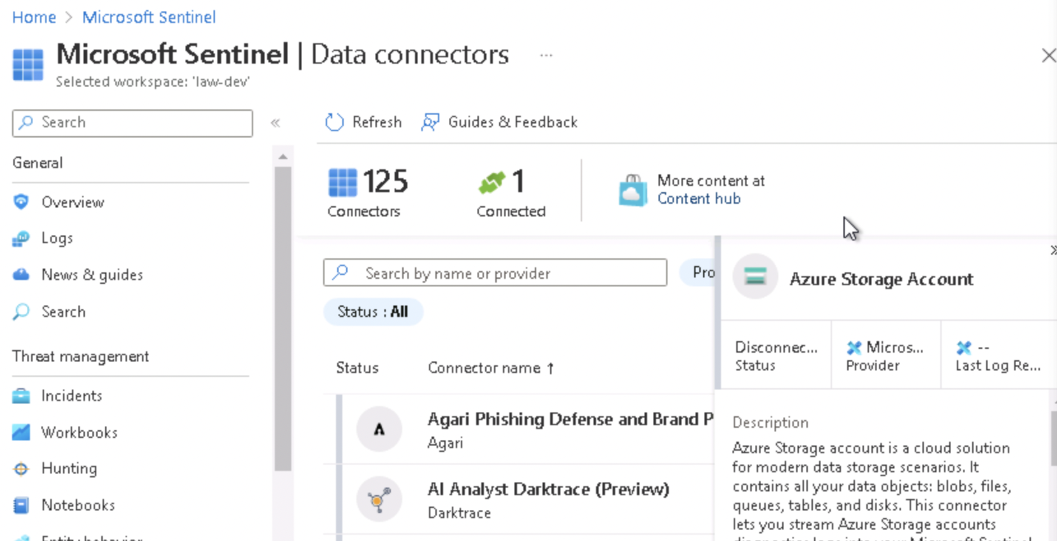

**Compliance**

1. Proof of NIST SP 800-53 rev4 policy added

